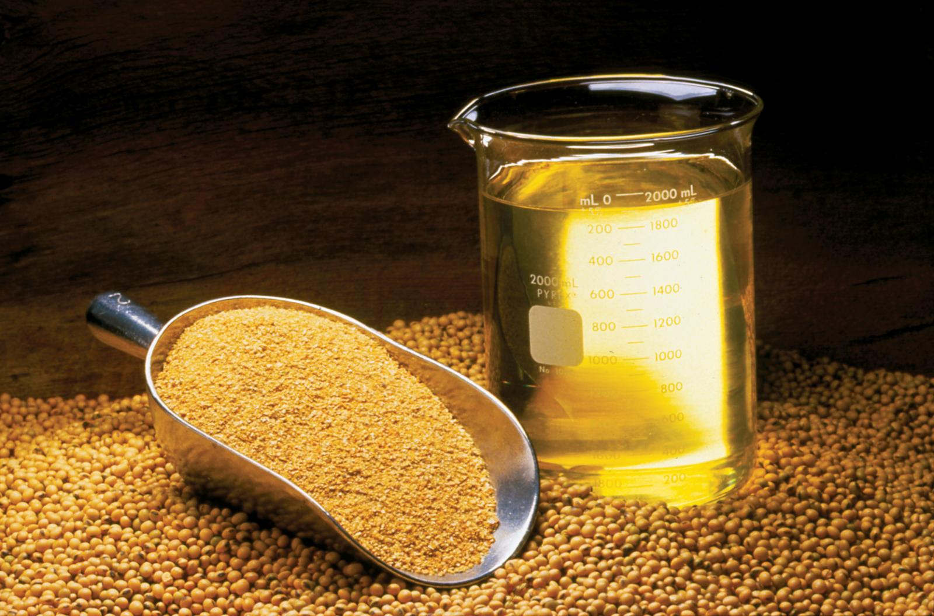

* 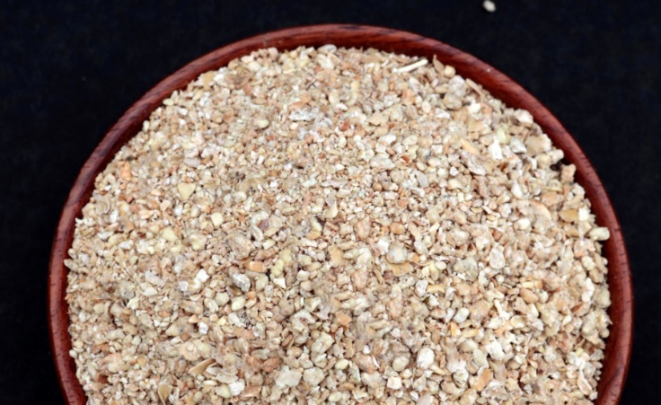**Soybean Meal**

Rama Gum Industries (i) Ltd is one of the main suppliers and global exporters for high-quality soybean meal in India.

* **Product Description**

Soybean cake, oil meal, oil cake, ground soybean chips, or ground soybean flakes, it works as an excellent source of protein for animal feed as it contains the highest level of lysine of the plant protein concentrates. In practice, it is usually fed in combination with other protein sources.

**Applications:**

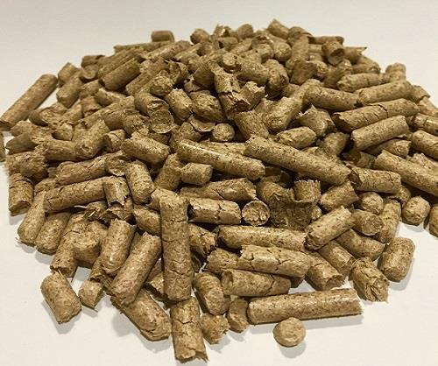

* A palatable source of protein, it is the dominant source in the rations of most farm animals, poultry and fish. It constitutes two-thirds of the total world output of protein feedstuffs.

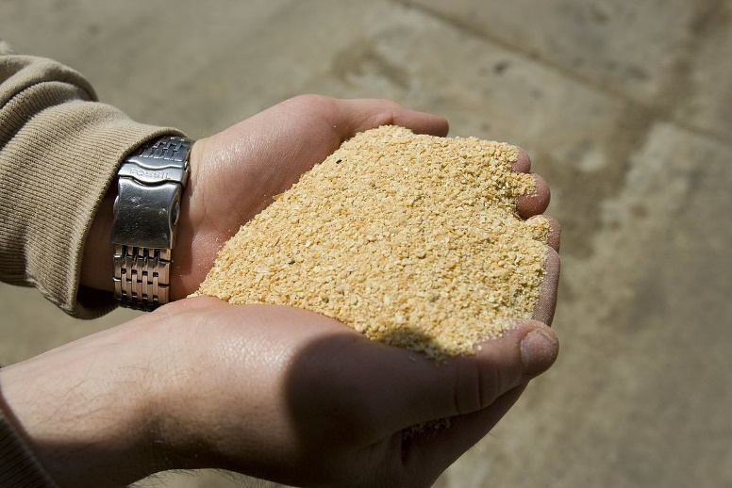

* Used in food products as protein alternatives and soymilk, especially in bakery products. Also used to make defatted soy flour, soy protein concentrates and textured soy protein products.

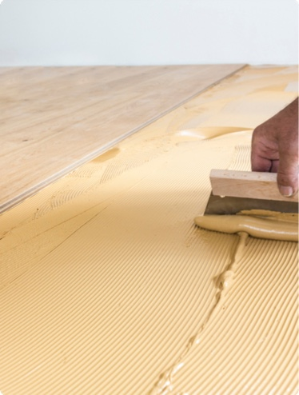

* Soybean meals are used across industries as soy wood adhesive, paper coatings, lubricants, cleaners and other environmentally-friendly products

**Specifications:**

|  |  |  |  |  |  |
| --- | --- | --- | --- | --- | --- |
|  |  | **Standard Soybean Meal** | **Hipro  Soybean Meal** | **Dehulled Hipro Soy Meal** | **Dehulled Super Hipro Soy Meal** |
|  |
| Protein | %(Min.) | 46 | 48 | 49 | 50 |  |
| Moisture | %(Mix.) | 12 | 11 | 11%Max | 10 |  |
| Acid Ins. Ash | %(Mix.) | 2.5 | 1.5 | 1 | 1/td> |  |
| Total Ash | %(Mix.) | 7.5 | 6.5 | 6.5 | 6.5 |  |
| Fiber | %(Mix.) | 7 | 6 | 4.5 | 4 |  |
| Fat | %(Mix.) | 1.5 | 1.5 | 1.5 | 1.2 |  |
| KOH Sol. | %(Min.) | 75 | 75 | 75 | 75 |  |
| Urease Act. | Mg/N/G | 0.02-0.3 | 0.02-0.3 | 0.02-0.3 | 0.02-0.3 |  |

**STORAGE**

Soybean meal should be stored in a covered shed with a dry atmosphere.

**SHELF LIFE**

24 months after manufacturing.

**AVAILABLE IN: PP bags**

* 50 Kg jumbo bags
* Bulk in containers